**1.**

**2.**

**Build decision tree model using C5.0 function:**

Prediction accuracy on training data using C5.0() function = (455+99)/666*100% = **83.2%**

**3.**  Apply the model to the testing dataset:

Prediction accuracy on validation data using C5.0() function = (208+38)/334*100% = **73.65%**

**Alternative (tree function)**

Prediction accuracy on training data using tree() function = (455+55)/666*100% = **76.58%**

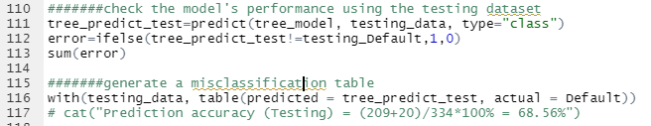

Prediction accuracy on validation data using tree() function = (209+20)/334*100% = **68.56%**